1. **Describe the software packages you use to implement the user interface**

I used MySQL, NetBeans and JavaServer Pages on NetBeans. I attached the zip file of both of my NetBeans project and MySQL database.

The user interface I created:

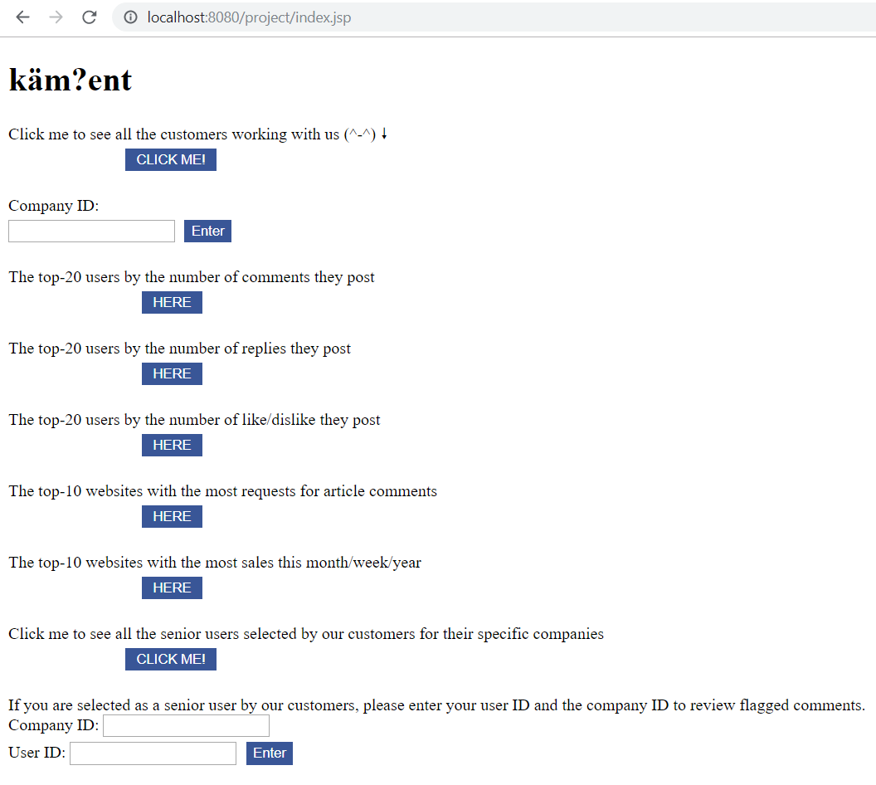

1. **Screen captures that shows that you implemented the interface**
2. **Customer:** the customer uses this page to ask for one or more news articles to be opened for user commenting

**The JSP file and code to list all the customers from the database to the user interface:**

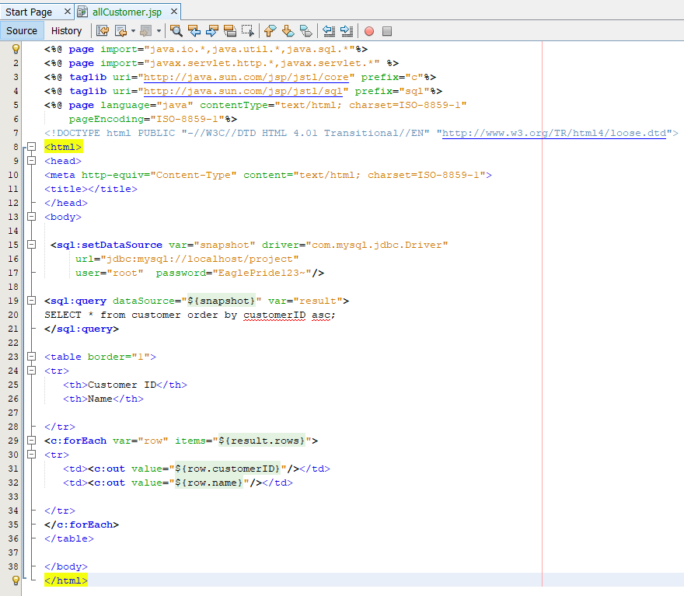

**List of Customers:**

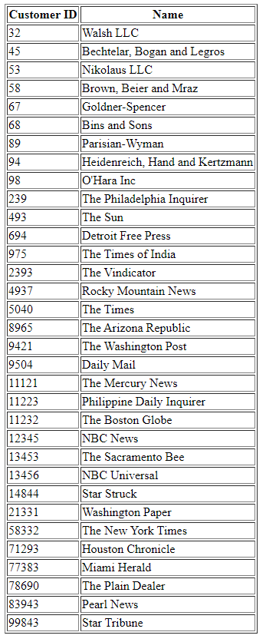

**Enter a specific customer ID to retrieve articles to open for commenting:**

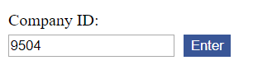

**The user interface of the specific customer ID retrieved:**

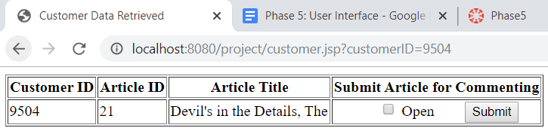

1. **Senior Users:** the senior users get a list of comments that were flagged as derogatory. Each comment has a checkbox that the user uses to tag the comment with YES/NO derogatory. You need to save that in the database

**The JSP file and code to list all the senior users from the database to the user interface:**

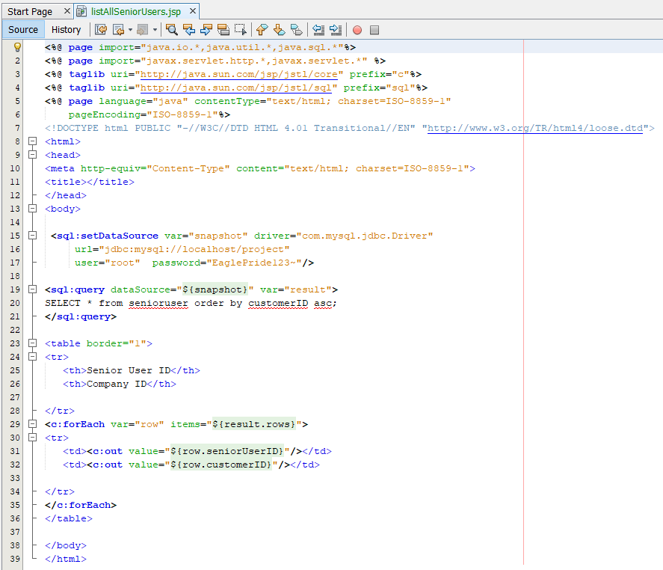

**List of all senior users:**

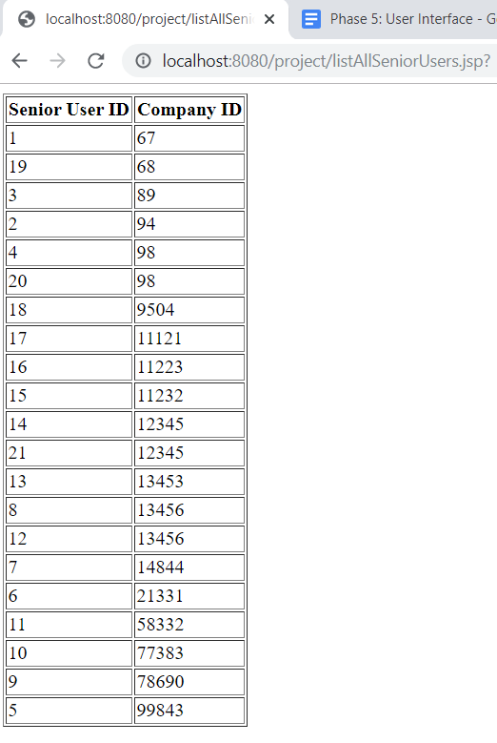

**User Interface to retrieve user comments and mark them as derogatory**

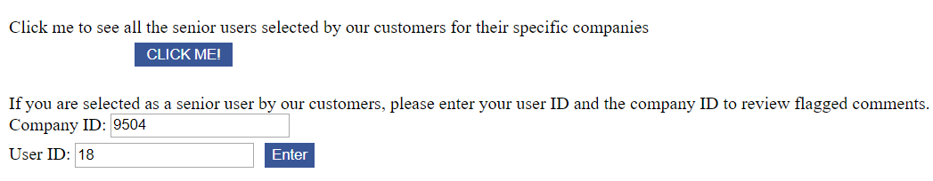

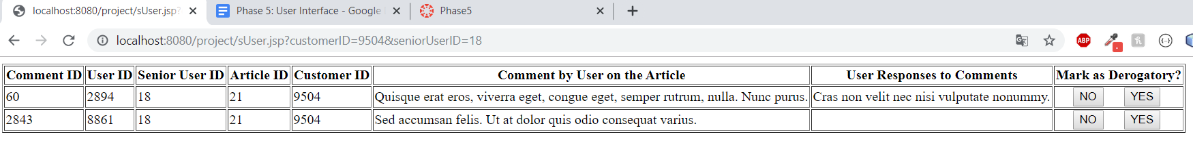

1. **Aggregates:** Create a web page that your startup can use to monitor the traffic it manages. Use some of the queries from phase 4

**Phase 4 - 1.**

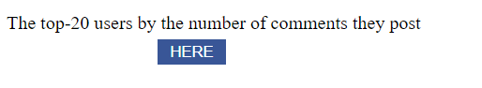

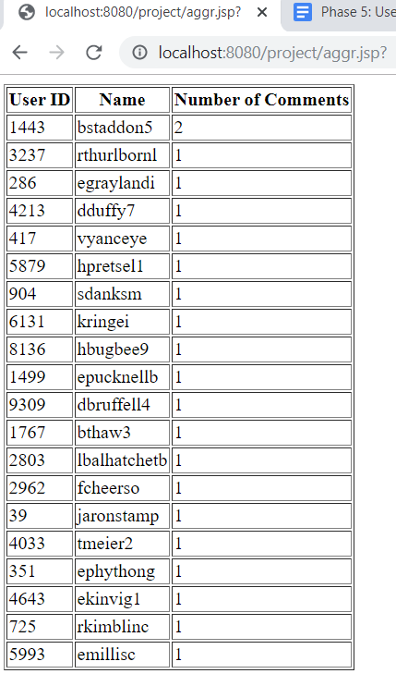

**Phase 4 - 2.**

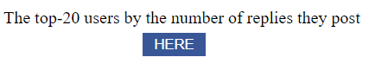

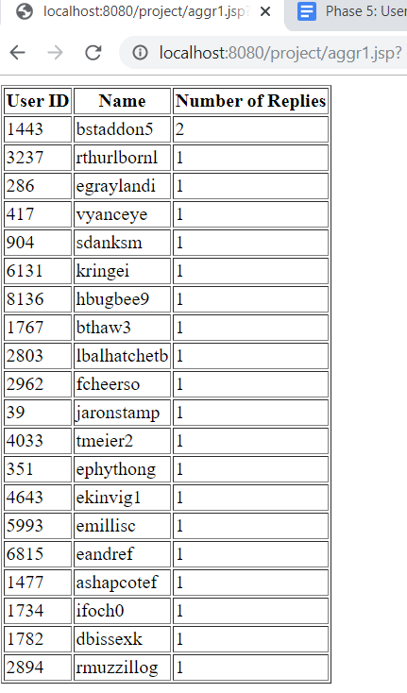

**Phase 4 - 3.**

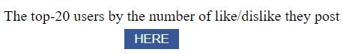

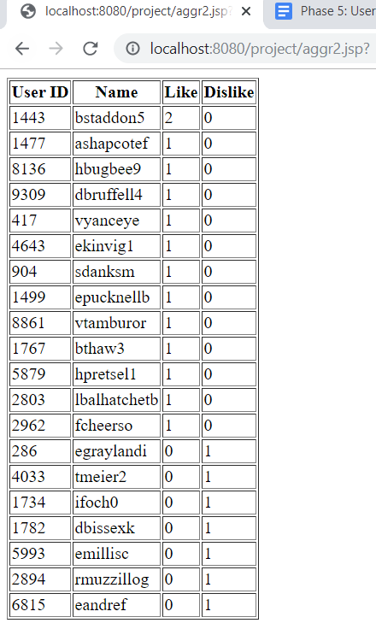

**Phase 4 - 4.**

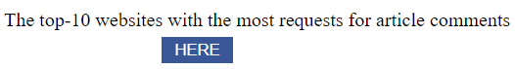

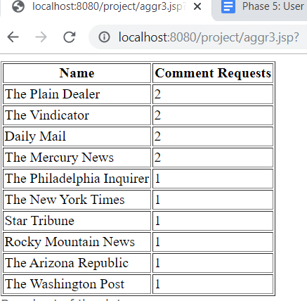

**Phase 4 - 5.**

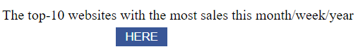

**Specifically for 22-09-2019**

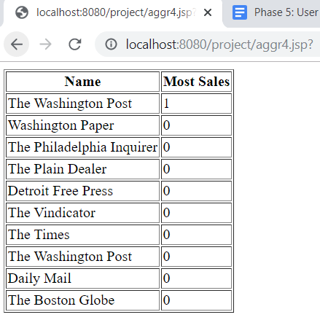

1. **Backend:** When a customer sends an article for commenting, inserts into your database K (say 100) dummy comments for each news article. Insert in some comments at random words that can be viewed as signals that a comment is derogatory. For example, you create list of curse words and insert one or two such words in 10% of the comments. Create a toy Java application that does this. Or, use a trigger

**Trigger to check for bad words**

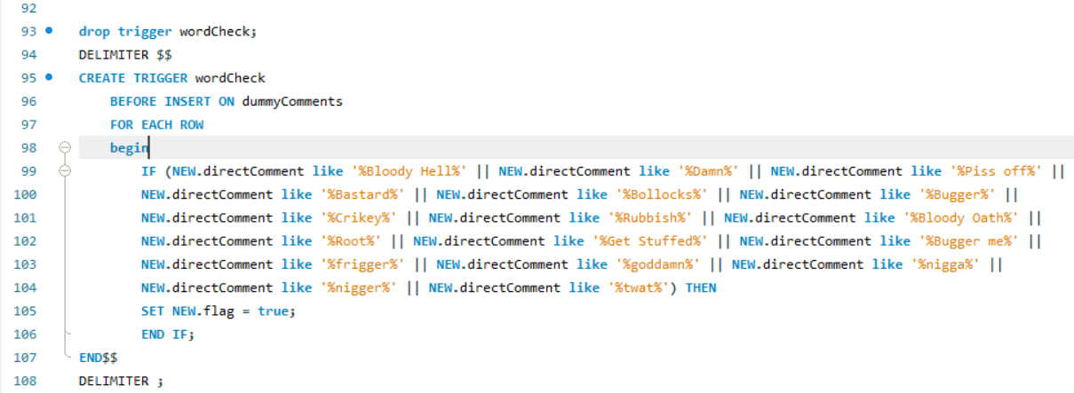

**The user interface to mark as open for commenting**

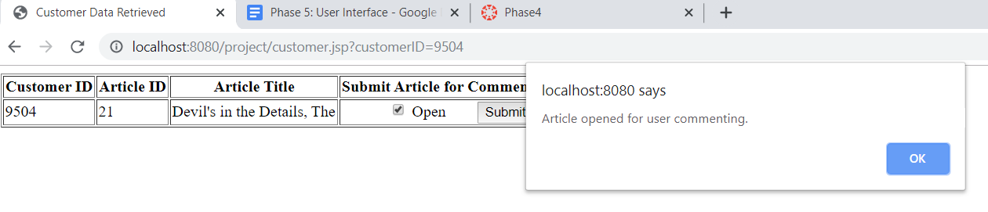

1. **Bonus:** Include plots in some of your web pages

I included one plot for **Phase 4 - 4.**

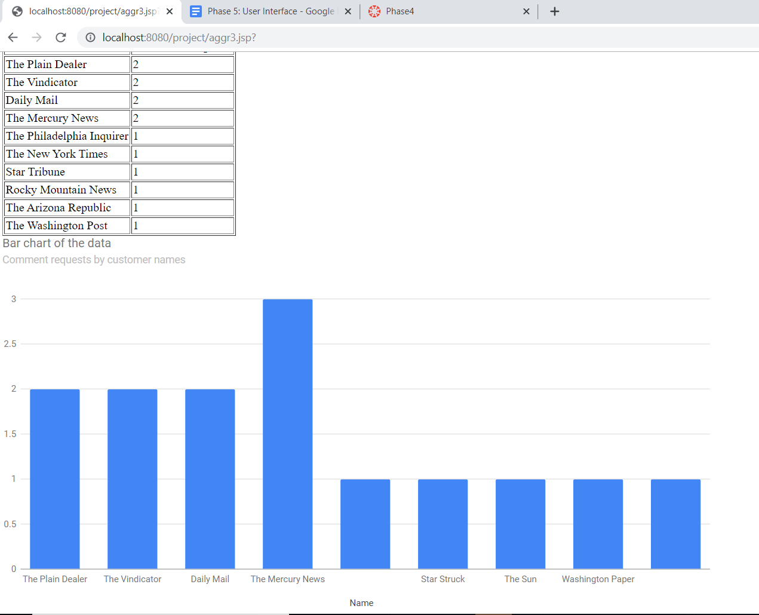

1. **Describe the challenges you met while implementing this phase of the project**

I faced many challenges while implementing phase 5. My first issue was matching versions. It took me at least 2 - 3 days to figure out that MySQL and NetBeans were at different versions and that is why I was having trouble connecting to MySQL via NetBeans. After fixing the version issue I was having trouble connecting to the database through JSP, so I emailed Dheera about it and she sent me a link that finally formed the connection between my user interface, the JSP files and my database.

It was definitely a huge learning process and getting familiar with HTML, Java Script and JSP coding.

I fixed the button issue after talking with the professor and TA.